Project Design Phase-II
Data Flow Diagram & User Stories

Date | 29 September 2026
Team ID | 6ab3d326a238dc999eb36ed1
Project Name | AI Weather Wise API
Maximum Marks | 4 Marks

Data Flow Diagram – AI WeatherWise API
The DFD shows how data flows through the AI WeatherWise API from the user to the weather service, Gemini AI, and MongoDB.
Flow:
User → API Server → Authentication → Weather API → Gemini AI → MongoDB → Response

Example: (Simplified)
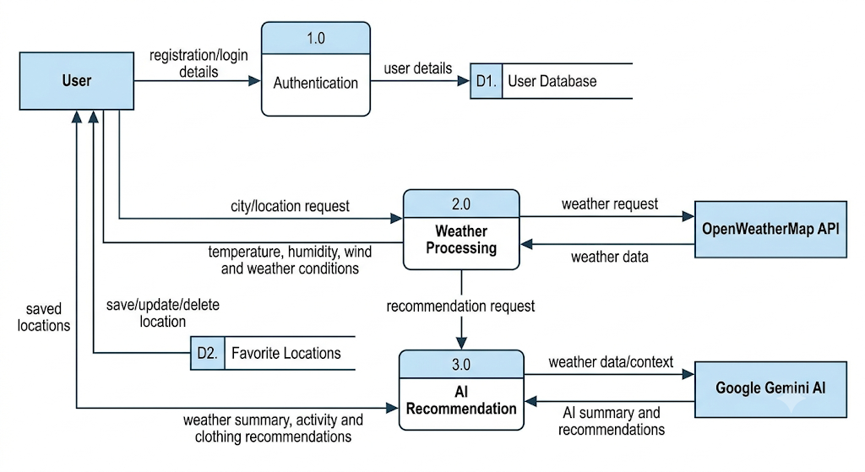

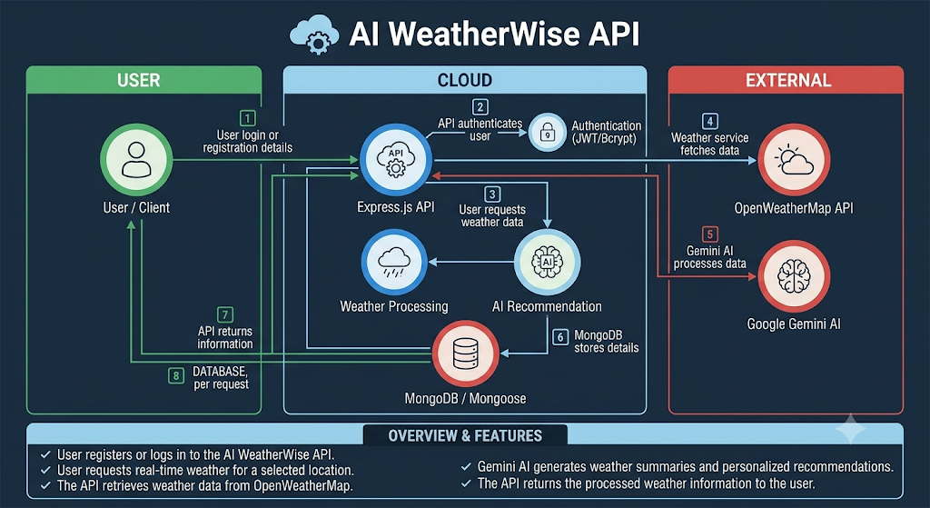

User Stories
User Type | Functional Requirement (Epic) | User Story Number | User Story / Task | Acceptance Criteria | Priority | Release
User | Registration | USN-1 | As a user, I can register using my name, email and password. | User account is created successfully with valid details. | High | Sprint-1
User | Login | USN-2 | As a user, I can log in using my email and password. | Valid credentials allow successful login. | High | Sprint-1
User | Security | USN-3 | As a user, my password should be securely hashed. | Password is stored securely using bcrypt. | High | Sprint-1
User | Authentication | USN-4 | As a user, I receive a JWT token after successful login. | Valid JWT token is generated and returned. | High | Sprint-1
User | Authentication | USN-5 | As a user, I can access protected APIs using my JWT token. | Unauthorized requests are rejected. | Medium | Sprint-1
User | User Management | USN-6 | As a user, my account details are stored in MongoDB. | User data is successfully saved in the database. | High | Sprint-1
User | Validation | USN-7 | As a user, I receive validation errors for missing or invalid details. | Invalid input returns an appropriate error message. | Medium | Sprint-1
User | Database | USN-8 | As a system, I can connect to MongoDB using Mongoose. | Database connection works successfully. | High | Sprint-1
User | Weather Management | USN-9 | As a user, I can request weather information for a city. | Weather data is returned for a valid city. | High | Sprint-2
User | Weather Management | USN-10 | As a user, I can view temperature, humidity, wind and weather conditions. | Required weather details are displayed correctly. | High | Sprint-2
User | Favorite Locations | USN-11 | As a user, I can save a favorite location. | Location is stored successfully. | High | Sprint-2
User | Favorite Locations | USN-12 | As a user, I can view my saved locations. | Saved locations are returned for the logged-in user. | Medium | Sprint-2
User | Favorite Locations | USN-13 | As a user, I can update or delete a favorite location. | Location is updated or removed successfully. | Medium | Sprint-2
User | Error Handling | USN-14 | As a user, I receive an error for an invalid city or weather request. | Appropriate error response is returned. | High | Sprint-2
User | Weather API | USN-15 | As a system, I can fetch real-time weather data from OpenWeatherMap. | Weather API returns valid real-time data. | High | Sprint-2
User | AI Features | USN-16 | As a user, I can receive an AI-generated weather summary. | Gemini generates a clear weather summary. | High | Sprint-3
User | AI Recommendations | USN-17 | As a user, I can receive personalized activity recommendations. | Suitable activities are generated from weather data. | High | Sprint-3
User | AI Recommendations | USN-18 | As a user, I can receive clothing recommendations based on weather. | Appropriate clothing suggestions are generated. | Medium | Sprint-3
User | AI Integration | USN-19 | As a system, I can connect with Google Gemini AI. | Gemini API processes the weather information successfully. | High | Sprint-3
User | Fallback | USN-20 | As a user, I can receive a fallback response when AI service is unavailable. | System provides an alternative response without crashing. | Medium | Sprint-3
User | Error Handling | USN-21 | As a user, I receive proper HTTP responses for API errors. | Errors return clear messages and correct status codes. | High | Sprint-3
User | API Testing | USN-22 | As a developer, I can test registration and login APIs using Postman. | APIs return expected responses for valid and invalid inputs. | High | Sprint-4
User | API Testing | USN-23 | As a developer, I can test weather and favorite-location APIs. | Weather and location APIs work correctly. | High | Sprint-4
User | API Testing | USN-24 | As a developer, I can test AI recommendation APIs using Postman. | AI responses are generated successfully. | High | Sprint-4
User | Documentation | USN-25 | As a developer, I can document the system architecture, ER diagram and API workflow. | Project documentation is complete and understandable. | Medium | Sprint-4
User | Demonstration | USN-26 | As a team, we can demonstrate the working AI WeatherWise API. | Main project features are successfully demonstrated. | High | Sprint-4
User | Integration | USN-27 | As a system, all modules work together as a complete API. | Authentication, weather, favorites and AI modules work correctly together. | High | Sprint-4

